**Health Inspection Dataset Analysis**

**Team Health Inspection**

**Ryan Permenter, Rachel Podemski, Clarence Robinson, Brett Thompson**

**26 February 2021**

**OVERVIEW**

This dataset contains details of health inspections and scores in the greater Dallas area dating back to October 2016. There are a total of 51,679 individual inspections, with each report containing the name of the establishment inspected, the physical location of the establishment, the date the inspection was conducted, the overall score for the inspection, and the point deduction for the individual violations. The data is provided by the Dallas Code Compliance Services Department and is updated monthly on the Dallas Open Data website.

Questions to be asked from this dataset include: (1) Is there a trend of a specific restaurant’s inspection scores over time? (2) Do inspection scores vary by region? (3) Is there a correlation between the number of violations and total inspection score? (4) Where are the “best/worst” places to eat in the greater Dallas area?

**DATA & MODELING APPROACH**

The original dataset was available in multiple forms (CSV, JSON, API). Multiple processes were utilized to extract and visualize the data to answer specific questions. After confirming cleanliness of the data, JSON data was extracted from the Socrata Open Data API (SODA) for the ability to filter, query, and aggregate. Additionally, the CSV containing the most recent 51,000 health inspections was downloaded from the Dallas Open Data website. A column was added to the CSV to calculate the total number of violations per restaurant, then all additional columns were deleted so that only “Establishment Name”, “Inspection Score”, and “Total Number of Violations” remained. No additional pre-analysis work was required to use this dataset.

Several different methods were utilized to answer specific questions from the dataset: (1) A line graph was designed from JSON data extracted with the SODA API and developed through Plotly to visualize trends of restaurant health inspection scores over time. (2) A similar approach was implemented and a bar graph was developed through Plotly to visualize inspection scores filtered by zip code. (3) A scatter plot was designed with Plotly using data from the CSV file to visualize the impact on inspection score versus total violations. (4) A heatmap was generated with Leaflet.js to visualize areas in Dallas that had a concentrated amount of either “high” or “low” inspection scores.

**RESULTS OF DATA ANALYSIS**

*(i) Is there a trend of a specific restaurant’s inspection scores over time?*

Health Inspections are conducted at-least every six-months. There are a few instances where a health inspection is conducted multiple times that will be discussed later. The line graph below shows the trend of two restaurant’s (OLIVE GARDEN and CHIPOTLE) over the past four years.

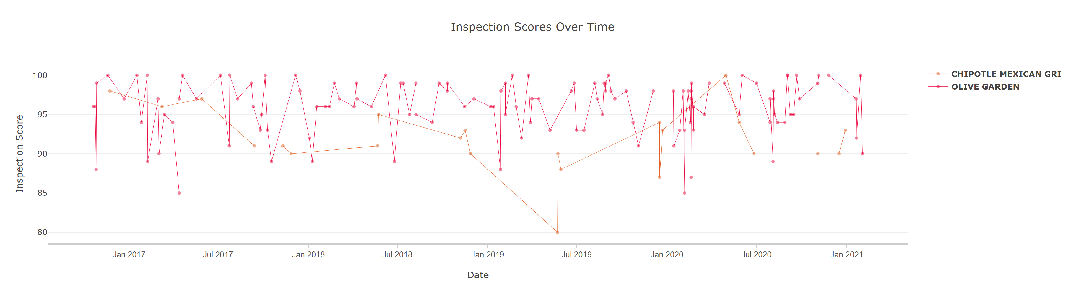

(ii) *Do inspection scores vary by region?*

The data is aggregated by zip code and the results shown are the average inspection score for each respective zip code in the Greater Dallas area. The results are sorted from lowest average inspection scores to highest and filter are applied to visualize any average results below a 90 overall score.

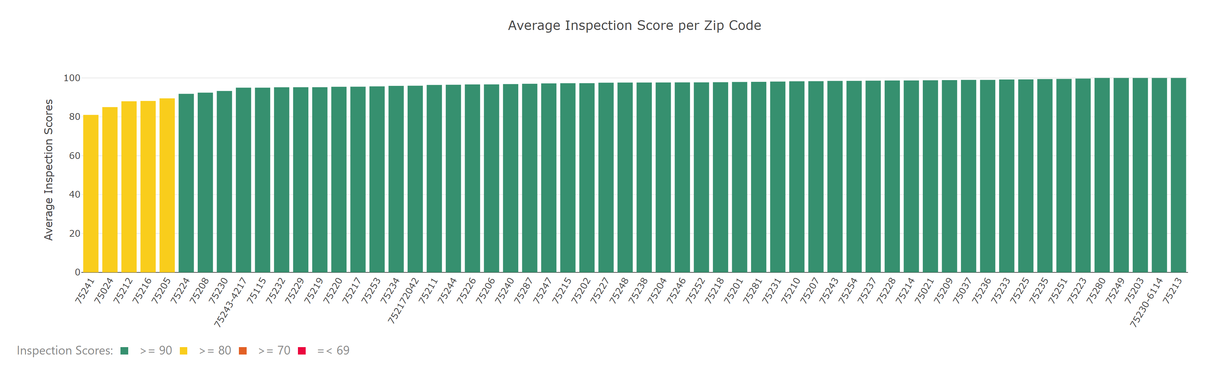

There are a total of three types of inspections seen the dataset. They are (1) Routine, (2) Follow-Up, and (3) Complaint. A routine inspection occurs at least once every 6-months for each restaurant. A Follow-Up inspection occurs within one-week and is the result of poor sanitation issues or low overall inspection scores. A Complaint inspection occurs as the result of a complaint from a patron regarding general sanitation/hygienic practices/illness investigation, smoking, or other incidents. The results of each type of inspection were filtered into buckets visualized in a bar graph.

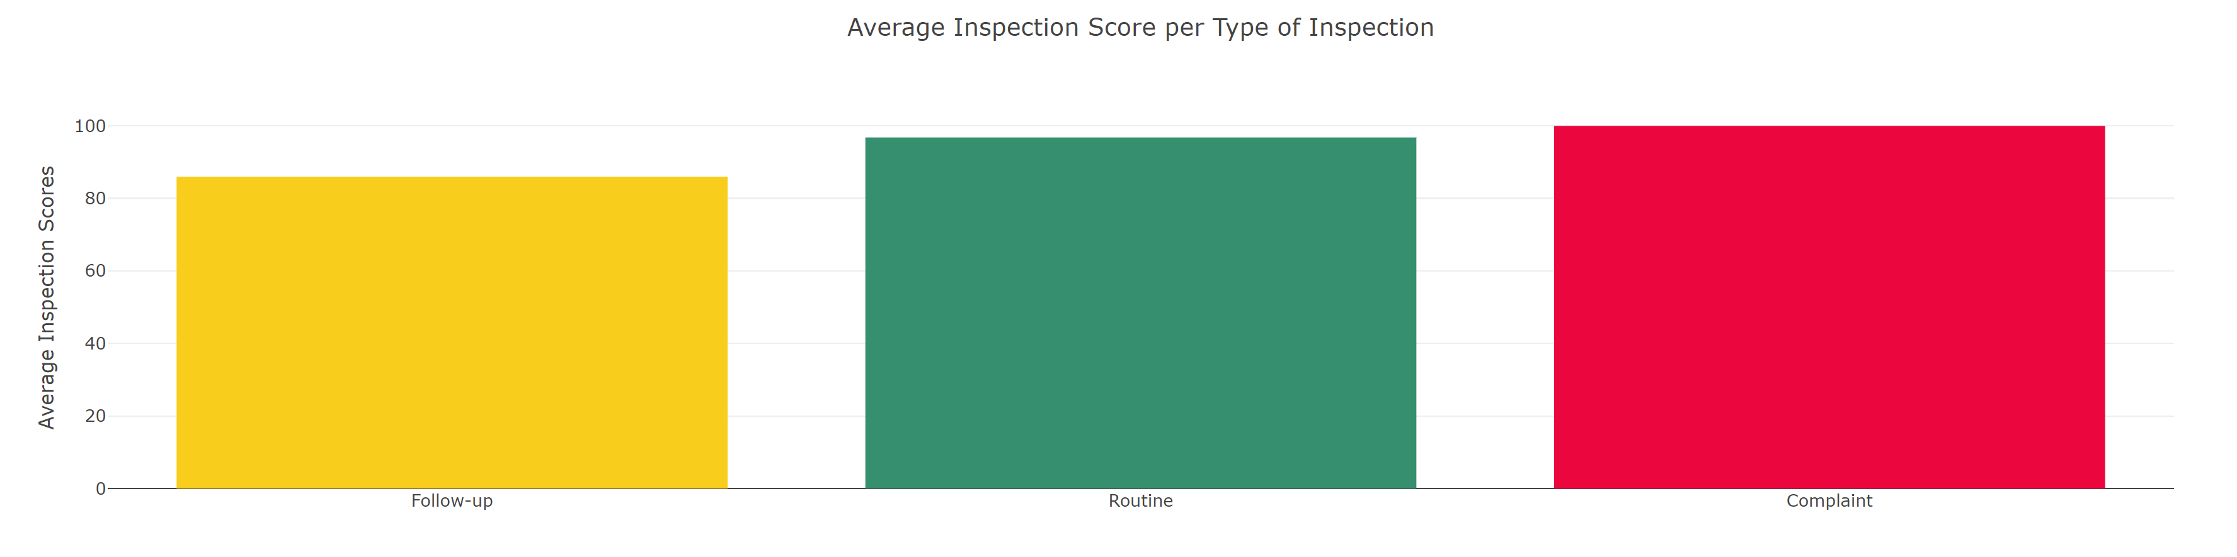

(iii) Is there a correlation between total number of violations and overall inspection score?

Most violations have a standard 1-point deduction in overall score. There are a few instances when more than a 1-point deduction can occur if a violation is extreme enough.

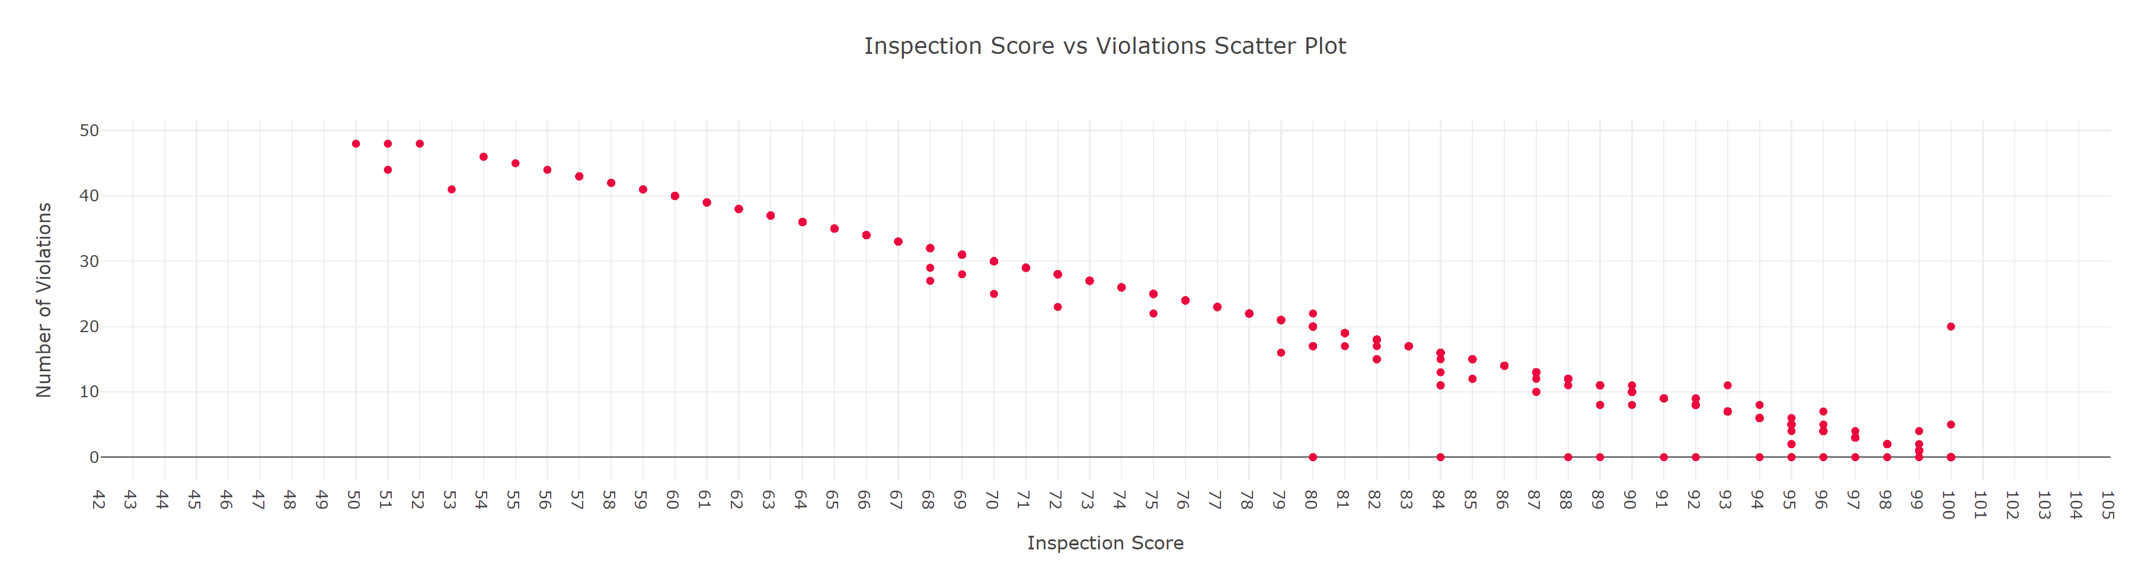

(iv) *Where are the best/worst places to eat in Dallas?*

The heatmap visualizes areas of Dallas where lower/higher inspection scores are concentrated. Red areas on the map denote locations that have a larger concentration of low inspection scores.

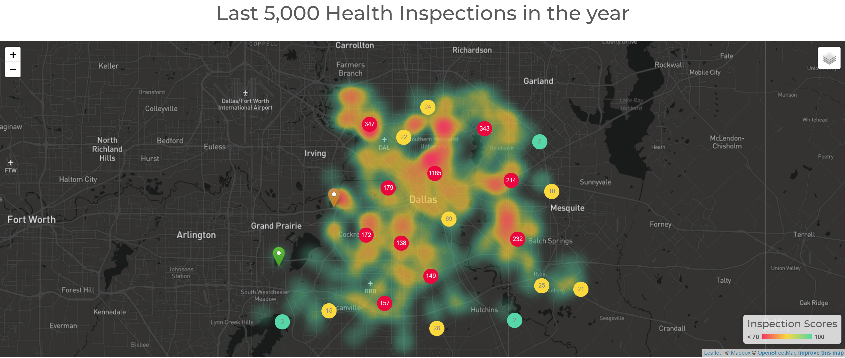

**CONCLUSIONS**

The food establishments at the intersection of Know Street & IH-75 have had consistently lower health inspection scores compared to the greater Dallas area for the past 4-years.

The food establishments to the Northwest of Dallas Love Field also tend to have lower inspection scores in the past 4-years.

Taking a sample size of 5,000 data points, on average most zip codes have an inspection score equal to or grater than 90.

When looking at the reason for the inspection, if the inspection occurred because of a “Complaint”, they tend to have a higher average inspection score than a “Routine” or “Follow-Up” inspection.

A lower inspection score usually resulted in a higher score during the “Follow-Up” inspection.

Violations and inspection score are inversely correlated. Meaning the more total violations a restaurant has, the lower the overall inspection score will be.

**RECOMMENDATIONS**

**LIMITATIONS/BIAS**

**WORKS CITED**

1. "**Leaflet** — An Open-Source Javascript Library For Interactive Maps". *Leafletjs.Com*, 2021, https://leafletjs.com/. Accessed 08 Feb 2021.
2. "**Pointhi/Leaflet-Color-Markers**". *Github*, 2021, https://github.com/pointhi/leaflet-color-markers/blob/master/js/leaflet-color-markers.js. Accessed 15 Feb 2021.